Unit 10 | Common Acids and Alkalis
Topic: Acid-base Indicators from plant materials
Worksheet
Name: ____________________
Class: ________________( )
Date: _____________________

Do you know that an acid-base Indicator changes colour in acidic and alkaline solutions?
The following solutions/liquids will be prepared by your teacher.
Solutions of different acidity/alkalinity (e.g. dilute hydrochloric acid (HCl), dilute sodium hydroxide solution (NaOH), lemon juice, vinegar, distilled water, soap solution, diluted bleaching solution, baking powder solution etc.); Indicators – litmus, methyl orange, phenolphthalein; 95% ethanol

The following apparatus are available.
test tubes, boiling tubes, droppers, retort stand and clamp, Bunsen burner, knife/scissors, stirrer, glove, safety goggle

The following plant materials are provided.
flower petals of Hibiscus (大紅花), leaves of Red Cabbage (紅卷心菜) , roots of yellow ginger (黃薑)

1. Complete the following table on the colour of the 3 indicators on common solutions.

 | litmus | methyl orange | phenolphthalein
HCl(aq) | red | red | colourless
NaOH(aq) | blue | yellow | red
lemon juice | red | orange | colourless
vinegar | red | red | colourless
distilled water | violet | yellow | colourless
soap solution | blue | yellow | red
bleach solution | blue | yellow | red
baking powder solution | blue | yellow | red
2. Draft the steps that you will go through to carry out the investigation on extracting pigments from plant materials. Sketch your design of the setup.

Steps :  1 Weigh about 5-10 g of the plant materials. Cut them into small pieces.  2 Put the cut plant materials into a boiling tube containing about 40 cm³ of 95% ethanol.  3 Warm the ethanol in a beaker of hot water (about 80ºC) for about 5 minutes.  4 Filter the ethanol solution to obtain the pigment solution.  5 Warm the solution in a beaker of hot water  for about 5 minutes to concentrate the solution. | Sketch of the setup  (suggested answers)  - 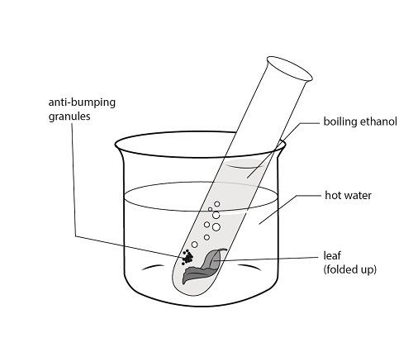  test tube  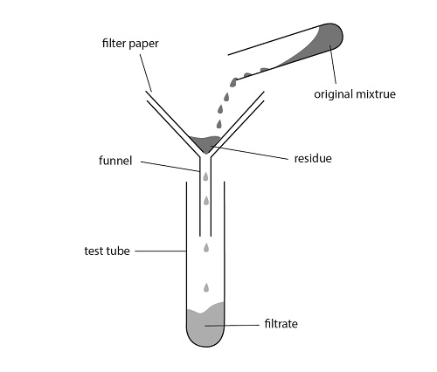  original mixture

3. Consider the advantage(s) and disadvantage(s) of the following two apparatuses in the
context of this investigation. Complete the following table.

 | Direct heating in test tubes | Indirect heating using Beakers
Advantage(s) | quick and easy to carry out | no naked flame – avoid the risk of fire
Disadvantage(s) | may catch fire when the vapour of ethanol evaporates | slower
4. What is your final choice of apparatus to hold the solution/liquid to be heated?

_____Use a hot water bath.______________________________________________

5. Suggest some essential safety precautions, with reasons, to be taken in the investigation.

Warm the ethanol solution using a hot water bath and keep the apparatus in a fume cupboard. Wear safety goggles to protect the eyes.

6. What measure(s) must be taken to increase the yield of the pigments?

1 Cut the plant materials into smaller pieces.

2 For roots like ginger, grind the pieces of ginger using mortar & pestle, together with about 5 cm³ of ethanol.

Results :
Complete the following table to show the colours of the pigments in acidic and alkaline solutions.

 | Hibiscus | Red cabbage | Yellow ginger
Acid - HCl(aq) | orange | red purple | yellow
Distilled Water | red | blue | orange
Alkali – NaOH(aq) | brown | green | red

7. What is an acid-base Indicator?

A substance which will show different colour in acid / base solutions._____________

8. What is an Universal Indicator ?

It is a mixture of indicators that can show different colours at different pHs._____

9. If an Universal Indicator can show different colours at different pH, suggest how it is
formed from the above pigments?

By mixing several suitable pigments such that it will show different colours at___
different pH values.__________________________________________________

10. What is the meaning of pH ? Suggest the pH for the solutions below.

It shows the relative strength of acids and alkalis. pH reflects the concentration of

the hydrogen ion (H⁺). At 25ºC, acidic solution has pH < 7 , while alkaline_______

solutionshas_pH>7.__________________________________________________

(Note: Dilute acid : pH≒1 Distilled Water : pH≒7 Dilute alkali: pH≒12)

11. What conclusion(s) can be drawn from this investigation?

Pigments can be extracted from some plant materials and these pigment solutions ___
are good acid-base indicators.____________________________________________

Extended Experiment :

Suggest other plant materials that can be used as acid-base indicator and try to extract them. Colour of the pigments in acids, distilled water and alkali.

Indicator/Pigment | Acid - HCl(aq) | Distilled Water | Alkali – NaOH(aq)
rose(玫瑰) petals
gladiolus(劍蘭) petals
blue berry (藍梅)
cherry (車厘子)
rhubarb (大黃)

A colour chart can be made using solutions of known pH to show the variation of
colour of these plant pigments.
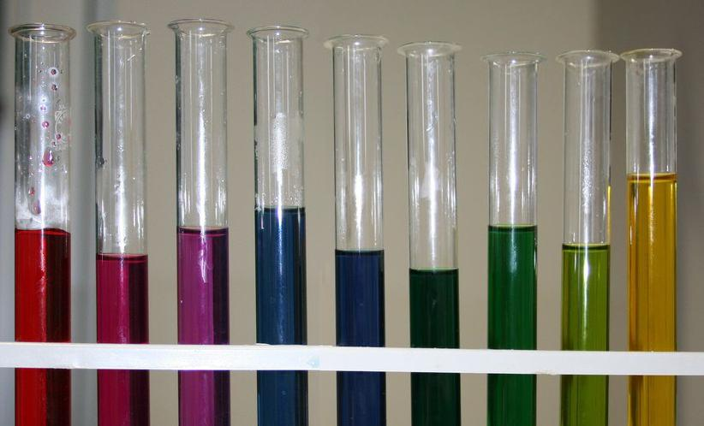

Red Cabbage pigment in different pH solutions

